
Mid-Term Report
ON
“MessMate: Digital Mess Management System”
IN
“DEPARTMENT OF COMPUTER SCIENCE AND ENGINEERING”
SUBMITTED IN PARTIAL FULFILLMENT OF THE DEGREE
OF
BE(CSE)
Under the Guidance of:  Name: [Guide Name]  Designation: [Designation]  Department: Computer Science & Engineering | Submitted By:  Name: Aakash Rana  University ID No.: 2311981005  Name: Aditya Antwal  University ID No.: 2311981035  Name: Anubhav  University ID No.: 2311981098
Chitkara University, Himachal Pradesh

Acknowledgement
We express our deepest gratitude to Chitkara University, Himachal Pradesh, and the Department of Computer Science and Engineering for providing us with the opportunity and the academic infrastructure to work on our project, “MessMate: Digital Mess Management System.”
We extend our heartfelt gratitude to our project guide and faculty mentors for their invaluable counsel, constant encouragement and continuous technical feedback throughout the design and implementation of this project. Their guidance has been crucial in establishing a robust application architecture and in adhering to academic standards.
Lastly, we acknowledge the collective team spirit and dedication of all group members – Aakash Rana, Aditya Antwal and Anubhav – whose synchronized efforts made the steady progress and successful mid-term realization of MessMate possible.

Preface
Managing institutional dining halls and university mess facilities involves high operational complexity. Daily challenges include estimating student turnout, planning raw inventory, managing meal bookings, handling entry check-ins, maintaining financial ledgers and resolving student grievances. Traditional paper-based registers or isolated offline applications often fail to deliver real-time operational coordination, leading to food overproduction, paper waste, long entry queues and unaccounted financial discrepancies.
This report presents MessMate, a full-stack web application designed to digitize and automate mess operations at Chitkara University. Prepared in accordance with the university’s guidelines for the Mid-Term Report, it covers the project introduction, feasibility study, requirement analysis, modules completed to date, detailed module analysis, system design (context diagram, DFD, flowchart and data dictionary), core code implementation, test cases and references.

Contents
Acknowledgement 2
Preface 3
1. Introduction to Project 5
1.1 Project Overview 5
1.2 Motivation and Key Functionalities 5
1.3 Technical Field and Core Technologies 6
2. Feasibility Study 7
2.1 Operational Feasibility 7
2.2 Technical Feasibility 7
2.3 Economic and Environmental Feasibility 7
2.4 Literature Review and Comparative Gap Analysis 7
3. Requirement Analysis 9
3.1 Software Requirements 9
3.2 Hardware Requirements 9
3.3 Functional Requirements 9
3.4 Non-Functional Requirements 9
4. Modules Completed Till Date 10
4.1 Development Methodology (Agile SDLC) 10
4.2 Completed Modules Matrix 10
4.3 Codebase Structure 11
5. Detailed Analysis of Individual Modules 12
5.1 Authentication and Role-Based Access Control (RBAC) 12
5.2 Dynamic Menu Management and Meal Booking Engine 12
5.3 Automated QR Code Entry and Attendance Verification 12
5.4 Centralized Inventory Management and Low-Stock Alerts 13
5.5 Grievance Redressal and Food Quality Feedback 13
5.6 Operational Reports and Predictive Demand Forecasting 13
6. Design 14
6.1 Context Diagram (Level 0 DFD) 14
6.2 Level 1 Data Flow Diagram (DFD) 15
6.3 QR Verification Workflow Flowchart 16
6.4 Data Dictionary and Data Schemas 16
7. Coding 18
7.1 Backend REST API (server.js) 18
7.2 Student Dashboard Handler (js/student-dashboard.js) 20
7.3 Manager Dashboard Handler (js/manager-dashboard.js) 22
8. Testing 24
8.1 Test Plan and Execution Strategy 24
8.2 Test Cases Matrix 24
9. Bibliography and References 25
9.1 Journals 25
9.2 Websites 25

1. Introduction to Project

1.1 Project Overview
MessMate is an end-to-end, full-stack digital mess management and automation platform designed to streamline administrative, kitchen and student dining operations in educational institutions such as Chitkara University. Conventional mess operations depend heavily on physical registers, which leads to paper wastage, inaccurate meal forecasting, food overproduction, slow complaint handling and billing discrepancies.
MessMate resolves these problems by consolidating all mess activities into a centralized, role-based platform offering real-time data analytics and automated workflows. Its primary objective is to minimize food wastage, enable precise meal planning, improve student satisfaction and automate administrative and financial processes. The system serves four user roles: Students, Mess Staff, Mess Managers and System Administrators.
Student | Mess Staff | Mess Manager | System Admin
Meal booking; Digital wallet; Ratings and feedback | Scan entry QR; Duty allocation; Real-time check-ins | Raw stock logs; Demand forecast; Waste analytics | User management; System audit logs; RBAC control

Table 1.1: Roles supported by MessMate

1.2 Motivation and Key Functionalities
The major objectives driving the development of MessMate are food waste minimization through dynamic booking and demand forecasting, automated QR-based attendance, supply-chain transparency through inventory tracking, financial accountability through digital wallets, and closed-loop grievance redressal. The platform delivers the following capabilities:
- Authentication and Role Management: multi-tenant Role-Based Access Control (RBAC) for Students, Mess Staff, Mess Managers and System Administrators.
- Role-Specific Dashboards: tailored web interfaces with KPI cards, charts and actionable operational widgets.
- Menu Management: digital publication, modification and scheduling of daily and weekly menus (Breakfast, Lunch, Snacks, Dinner).
- Meal Booking and Cancellation: interactive opt-in / opt-out for students, governed by time cut-off rules.
- Attendance Verification: automated entry validation using dynamic student QR codes and instant staff scanning.
- Feedback and Rating Engine: post-meal 1-to-5 star ratings with qualitative comments.
- Grievance Redressal: ticket submission with real-time status updates (Pending, In Progress, Resolved).
- Inventory Management and Low-Stock Alerts: real-time tracking of raw supplies with automated threshold warnings.
- Wastage and Sustainability Analytics: daily logging of discarded food weight and demand estimation based on historical trends.
- Financial Wallet and Invoicing: digital student wallet with transaction history, ledger entries and receipt generation.

1.3 Technical Field and Core Technologies
MessMate operates in the domain of Web Application Development, Cloud Computing and Operational Data Analytics. The technology stack is summarized below.
Layer | Technology
Frontend | HTML5, CSS3, JavaScript (ES6+), modular stylesheets (CSS variables, responsive grid layouts)
Backend | Node.js with Express.js (RESTful API server architecture)
Data and Storage | JSON-backed persistence with MongoDB / PostgreSQL support
Security and Auth | JSON Web Tokens (JWT) and BCrypt password hashing
Visualization | Custom JavaScript canvas chart engine for real-time dashboards

Table 1.2: MessMate technology stack

2. Feasibility Study

2.1 Operational Feasibility
MessMate is designed to integrate into existing university dining operations with minimal friction. Its workflows cater to four roles:
- Students: access a mobile-first dashboard to view menus, toggle meal reservations, check wallet balances, generate QR entry codes and submit complaints.
- Mess Staff: use a simple interface to scan student QR codes and manage daily kitchen checklists.
- Mess Managers: oversee inventory levels, review demand forecasts, log food waste and resolve grievances.
- System Administrators: manage user accounts, enforce security protocols and review audit logs.
Minimal training is required, since staff only need to scan QR codes and update inventory counters.

2.2 Technical Feasibility
The platform is built on robust open-source technologies:
- Node.js and Express.js provide an asynchronous, event-driven backend capable of handling many concurrent requests during peak dining hours.
- Modular JavaScript client architecture keeps the payload small so dashboards render quickly on mobile devices.
- RESTful JSON endpoints are decoupled from the client UI, allowing future integration with physical QR scanners or RFID readers.

2.3 Economic and Environmental Feasibility
Economic benefit: the system eliminates costs associated with physical paper logs, manual receipt printing and over-purchasing of raw ingredients.
Environmental impact: by requiring meal cut-off bookings and using historical attendance trends for demand estimation, the system reduces discarded food and supports green-campus initiatives.

2.4 Literature Review and Comparative Gap Analysis
Academic literature highlights clear gaps in legacy hostel and dining operations:
- Manual ledger systems: Sharma and Verma (2019) noted that paper logs incur a 15–20% accounting error margin and cause heavy food waste due to the lack of prior headcount forecasting.
- Standalone desktop applications: Kumar and Singh (2020) concluded that offline database applications fail to provide real-time student interaction, missing features such as instant cancellation or live menu alerts.
- Entry-only RFID / QR tools: Patel et al. (2021) developed QR-based entrance gates; entry queues were reduced, but the platform lacked supply-chain management, financial wallets and waste analytics.

Functional Aspect | Traditional Mess Setup | Existing Desktop Tools | Proposed MessMate System
Meal Planning | Fixed / manual logs | Static digital menu | Dynamic booking and cut-off cancellation
Demand Forecasting | Static guesswork | Basic statistical average | Booking data with historical trend forecasting
Attendance Verification | Manual signature registers | Basic RFID / barcode entry | Instant QR code verification
Feedback and Grievances | Physical register / suggestion box | Google Forms / e-mail | Integrated rating engine and ticket tracker
Inventory Tracking | Paper ledger | Basic Excel sheets | Automated low-stock alerts and supplier logs
Waste Management | Unmonitored disposal | Unmonitored disposal | Daily waste logging and sustainability analytics

Table 2.1: Comparative gap analysis

3. Requirement Analysis

3.1 Software Requirements
- Operating System: Windows 10/11, macOS or Linux (Ubuntu LTS).
- Runtime Environment: Node.js (v18.x or higher).
- Framework: Express.js (v4.x) REST API framework.
- Development Tools: Visual Studio Code, Git, GitHub.
- API Testing Tool: Postman / Insomnia.
- Web Browsers: Google Chrome, Mozilla Firefox, Safari, Microsoft Edge.

3.2 Hardware Requirements
- Processor: Intel Core i5 / AMD Ryzen 5 (2.4 GHz or higher).
- RAM: 8 GB minimum (16 GB recommended).
- Storage: 256 GB SSD (minimum 10 GB free space).
- Display / Test Devices: Full HD monitor (1920x1080) for development; Android/iOS smartphones for QR scanning tests.
- Network: high-speed local network / internet connection.

3.3 Functional Requirements
ID | Requirement | Description
FR1 | Authentication | Secure user authentication using email/password and JWT issuance.
FR2 | RBAC | Route-guard authorization distinguishing Student, Staff, Manager and Admin roles.
FR3 | Menu Control | Managers can update daily menus for all meal slots.
FR4 | Booking Engine | Students can reserve or cancel upcoming meals before designated cut-off times.
FR5 | QR Entry | Dynamic QR code generation for students and instant scanner validation for staff.
FR6 | Inventory Management | Ingredient inventory tracking with low-stock warning triggers.
FR7 | Grievance Handling | Complaint filing with status lifecycle (Pending → In Progress → Resolved).
FR8 | Analytics and Reports | Real-time generation of waste, attendance and expense reports.

3.4 Non-Functional Requirements
ID | Requirement | Description
NFR1 | Security | BCrypt password hashing and JWT-based authorization.
NFR2 | Performance | Sub-second response (< 200 ms) for QR code attendance verification.
NFR3 | Usability | Responsive UI adapting to mobile, tablet and desktop viewports.
NFR4 | Reliability | Error-handling middleware preventing server crashes on unexpected input.

4. Modules Completed Till Date

4.1 Development Methodology (Agile SDLC)
The project follows an iterative Agile Software Development Life Cycle, organized into sprints over a 12-week schedule.
Duration | Phase
Weeks 1–2 | Phase 1: Requirement gathering, system architecture and schema design
Weeks 3–4 | Phase 2: Express server setup, REST routes and JWT authentication
Weeks 5–8 | Phase 3: Core dashboards, QR scanner, booking and inventory UI
Weeks 9–10 | Phase 4: Operations reports, forecasting engine and global search
Weeks 11–12 | Phase 5: System integration, end-to-end testing and deployment

Table 4.1: Agile development timeline

4.2 Completed Modules Matrix
Module Name | Implemented Core Features | Status
Authentication and RBAC | JWT auth, password hashing, multi-role route guarding | Completed (100%)
Student Dashboard | Menu view, meal opt-in/opt-out, QR generator, wallet UI | Completed (100%)
Staff Dashboard | QR scanner simulation, entry validation, daily checklists | Completed (100%)
Manager Dashboard | Inventory tracker, demand forecasts, complaint resolver | Completed (100%)
Admin Dashboard | User role assignment, system auditing, RBAC rules | Completed (100%)
Grievance Module | Ticket creation, categorization, status progress updates | Completed (100%)
Operations Reports | Attendance analytics, wastage logging, PDF/Excel exports | Completed (100%)
Global Search Engine | Cross-module field search, multi-column filtering | Completed (100%)

Table 4.2: Modules completed till date

4.3 Codebase Structure
The repository follows a modular structure, separating pages, stylesheets and client-side controllers:
MessMate/
|-- server.js # Central Node.js & Express API server
|-- package.json # Dependency configuration
|-- index.html # Main application landing page
|-- signup.html # Unified authentication portal
|-- student-dashboard.html # Student management portal
|-- staff-dashboard.html # Mess staff operations portal
|-- manager-dashboard.html # Mess manager operations portal
|-- admin-dashboard.html # System administration portal
|-- css/ # Modular stylesheets
| |-- main.css # Base layout & design variables
| |-- brand-polish.css # Visual aesthetics & utilities
| |-- student-dashboard.css | staff-dashboard.css
| |-- manager-dashboard.css | admin-dashboard.css
| |-- operations-reports.css | global-search.css
|-- js/ # Frontend application controllers
|-- auth.js # Authentication & session engine
|-- student-dashboard.js # Student logic & booking handlers
|-- staff-dashboard.js # QR verification & scanner logic
|-- manager-dashboard.js # Inventory, complaints & forecasting
|-- admin-dashboard.js # User administration & audit logic
|-- operations-reports.js # Analytics engine & exports
|-- activity-report.js # Activity monitoring logic
|-- global-search.js # Universal client search engine

5. Detailed Analysis of Individual Modules

5.1 Authentication and Role-Based Access Control (RBAC)
The authentication module provides secure entry into the platform. On login, the backend validates the email and verifies the password against its BCrypt hash. It then issues a signed JSON Web Token (JWT) carrying the session data and the assigned role (STUDENT, STAFF, MANAGER or ADMIN). Client-side route guards read this token, redirect users to their designated dashboard and block access to elevated routes.

5.2 Dynamic Menu Management and Meal Booking Engine
Mess managers publish weekly menus across four meal slots: Breakfast, Lunch, Snacks and Dinner, which are rendered dynamically on the student dashboard. Students toggle their attendance (Opt-In / Opt-Out) for upcoming meals. To keep the kitchen stable, time cut-offs are enforced (for example, lunch bookings close at 09:00 AM), giving managers an exact headcount before preparation begins.
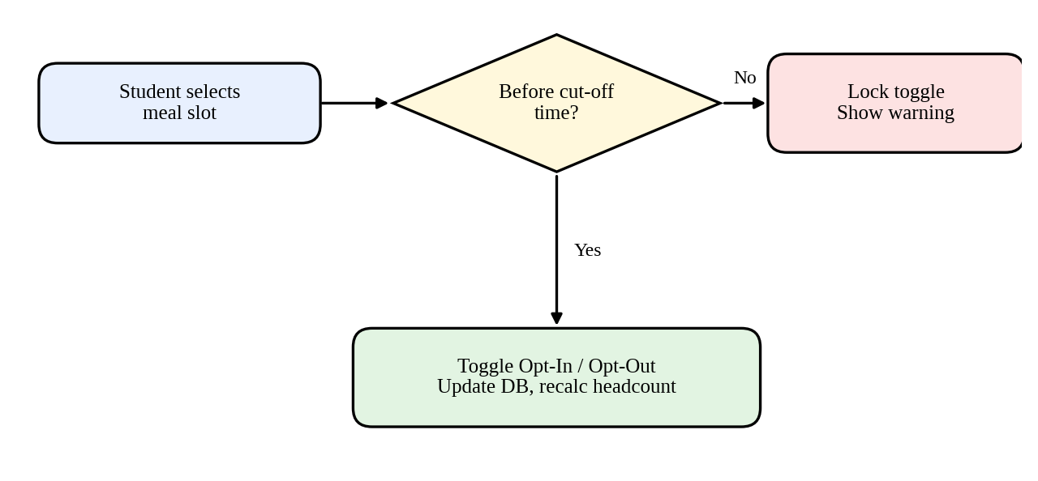
Figure 5.1: Meal booking and cut-off logic

5.3 Automated QR Code Entry and Attendance Verification
To prevent queue congestion, MessMate replaces manual signed ledgers with instant digital scanning:
- The student dashboard generates a dynamic QR code tied to the student’s ID, active session and date.
- Mess staff scan the code with a web camera or handheld device.
- The system verifies token validity, an active meal booking for the current time window, and the absence of a prior entry for the same meal slot.
- Approved scans update attendance in real time and mark the meal as CONSUMED; duplicate scans trigger a visual and auditory alert.

5.4 Centralized Inventory Management and Low-Stock Alerts
The inventory module tracks raw food ingredients, kitchen tools and cleaning supplies. Managers update stock quantities, record vendor purchases and log consumption rates. Each item has a minimum safety threshold; when stock falls below it, the item is highlighted and a low-stock notification appears in the manager’s action panel, supporting timely reordering.

5.5 Grievance Redressal and Food Quality Feedback
MessMate implements a closed-loop feedback engine:
- Post-meal ratings: students submit 1-to-5 star ratings with qualitative notes.
- Grievance ticketing: formal complaints are filed under Hygiene, Food Quality, Staff Behavior or Billing.
- Lifecycle management: tickets receive tracking IDs and are routed to the Manager Dashboard, where managers update the status (Pending → In Progress → Resolved), giving students transparency.

5.6 Operational Reports and Predictive Demand Forecasting
The operations module aggregates logs across attendance, inventory consumption, meal bookings and waste records:
- Predictive forecasting: combines active opt-in counts with historical attendance patterns to project demand for upcoming days, aiding purchasing decisions.
- Waste analytics: logs daily discarded food weight to track operational efficiency over time.
- Data export: reports can be downloaded in CSV, Excel or PDF formats for institutional auditing.

6. Design

6.1 Context Diagram (Level 0 DFD)
The context diagram shows the external entities interacting with the central MessMate system boundary.
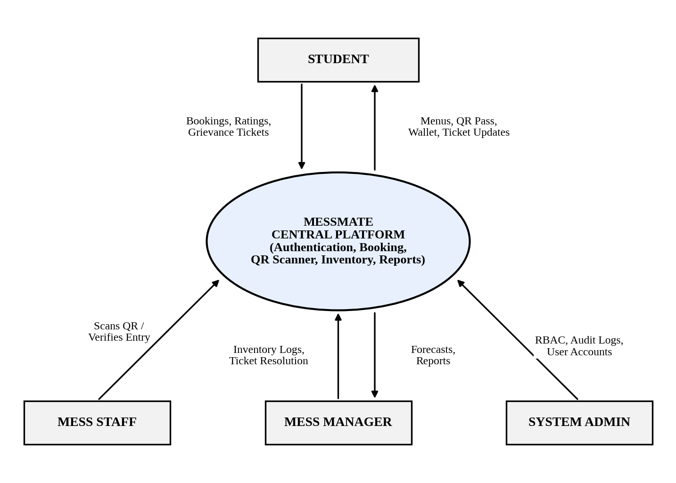
Figure 6.1: Context diagram (Level 0 DFD)

6.2 Level 1 Data Flow Diagram (DFD)
The Level 1 DFD outlines the internal processes and data stores of the system.
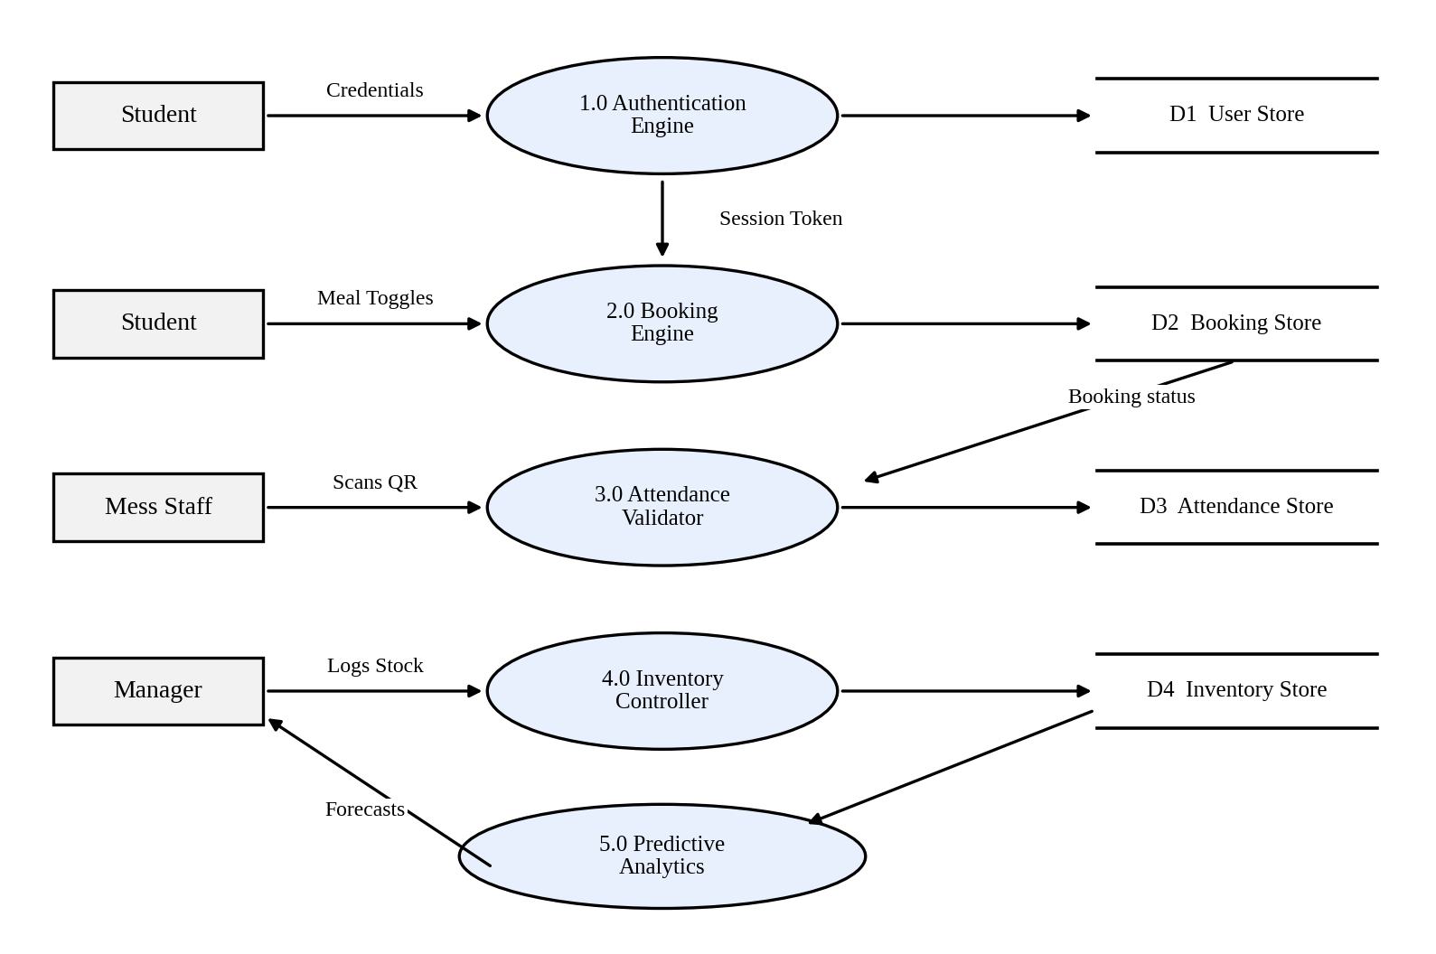
Figure 6.2: Level 1 data flow diagram

6.3 QR Verification Workflow Flowchart
The flowchart below shows the check-in logic applied when a student presents a QR pass at the mess entrance.
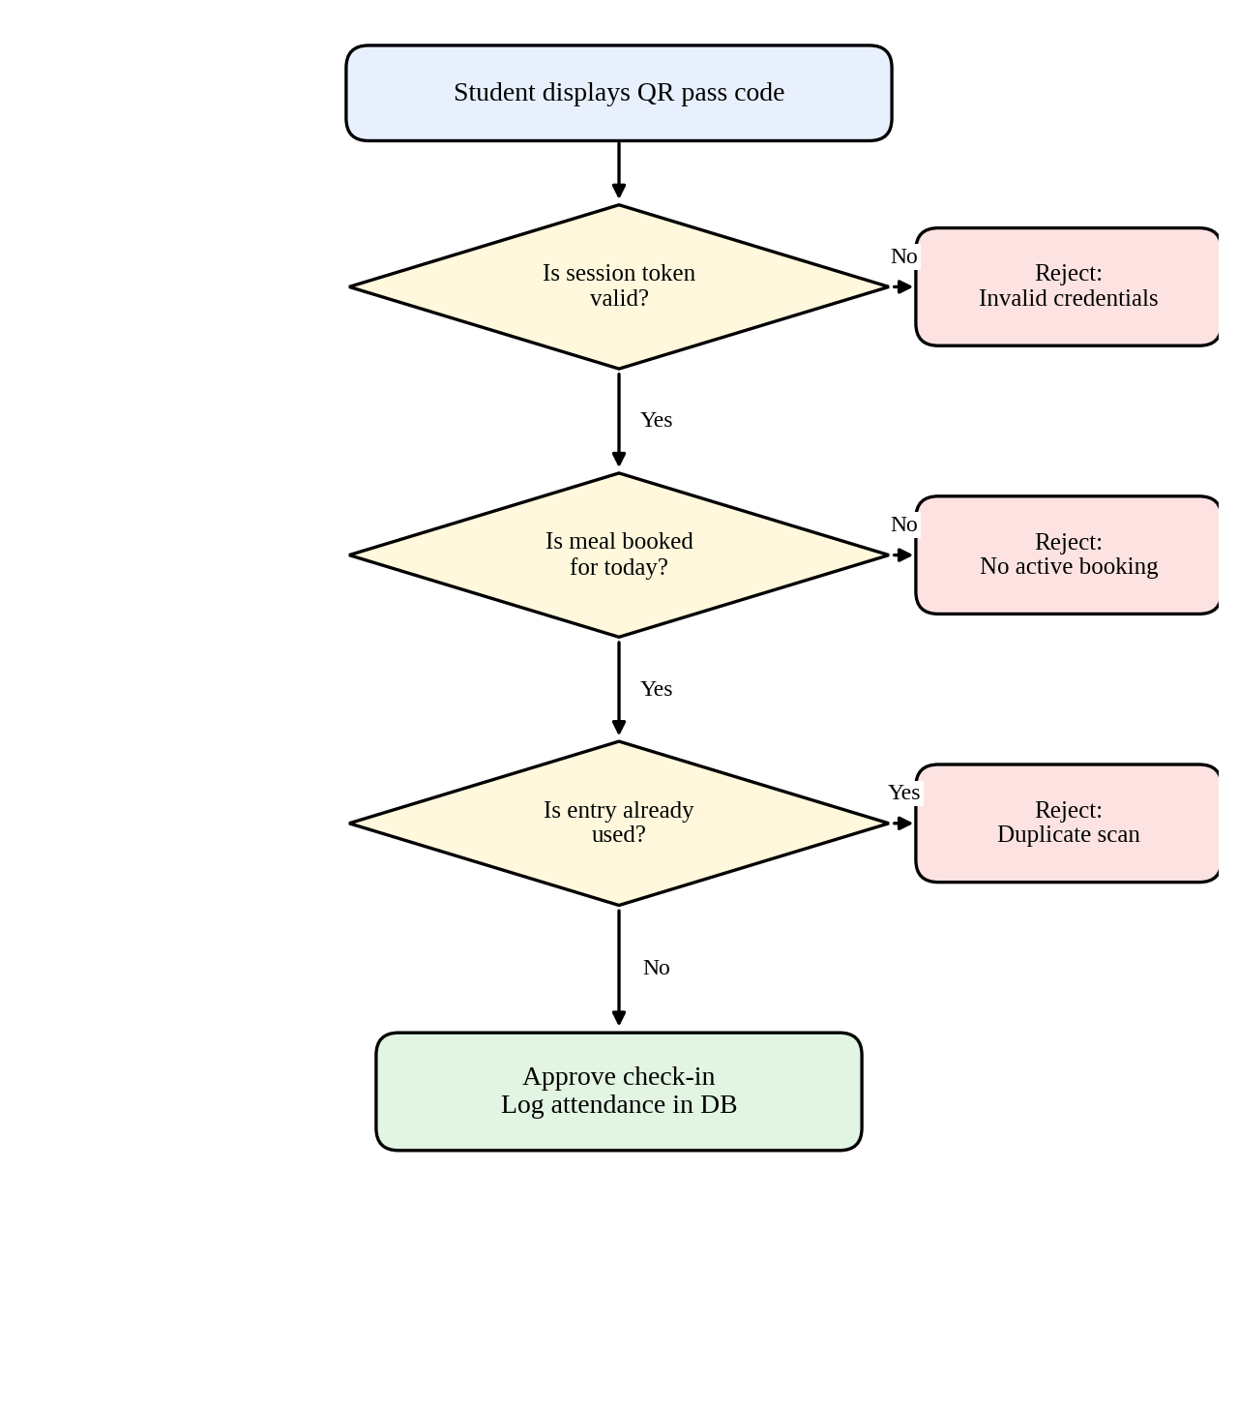
Figure 6.3: QR verification workflow

6.4 Data Dictionary and Data Schemas
Table 6.1: Users Schema
Field | Type | Description
user_id | String / PK | Unique user identification
name | String | Full name of user
email | String | Institutional email address
password_hash | String | BCrypt-encrypted password
role | Enum | STUDENT, STAFF, MANAGER, ADMIN
wallet_balance | Decimal | Current account funds balance
created_at | Timestamp | Account creation date

Table 6.2: Booking Schema
Field | Type | Description
booking_id | String / PK | Unique reservation reference
student_id | String / FK | References Users.user_id
booking_date | Date | Targeted meal date
meal_slot | Enum | BREAKFAST, LUNCH, SNACKS, DINNER
status | Enum | OPTED_IN, OPTED_OUT, CONSUMED

Table 6.3: Inventory Schema
Field | Type | Description
item_id | String / PK | Ingredient / supply reference
item_name | String | Display name of the raw item
category | String | Grains, Vegetables, Dairy, Supplies
current_stock | Float | Available quantity
unit_measure | String | KG, LITERS, PACKETS
min_threshold | Float | Minimum limit that triggers a low-stock alert

7. Coding

7.1 Backend REST API (server.js)
The primary Express application initializes the API endpoints, applies middleware and serves the static frontend. A prototype in-memory store is used for rapid development.
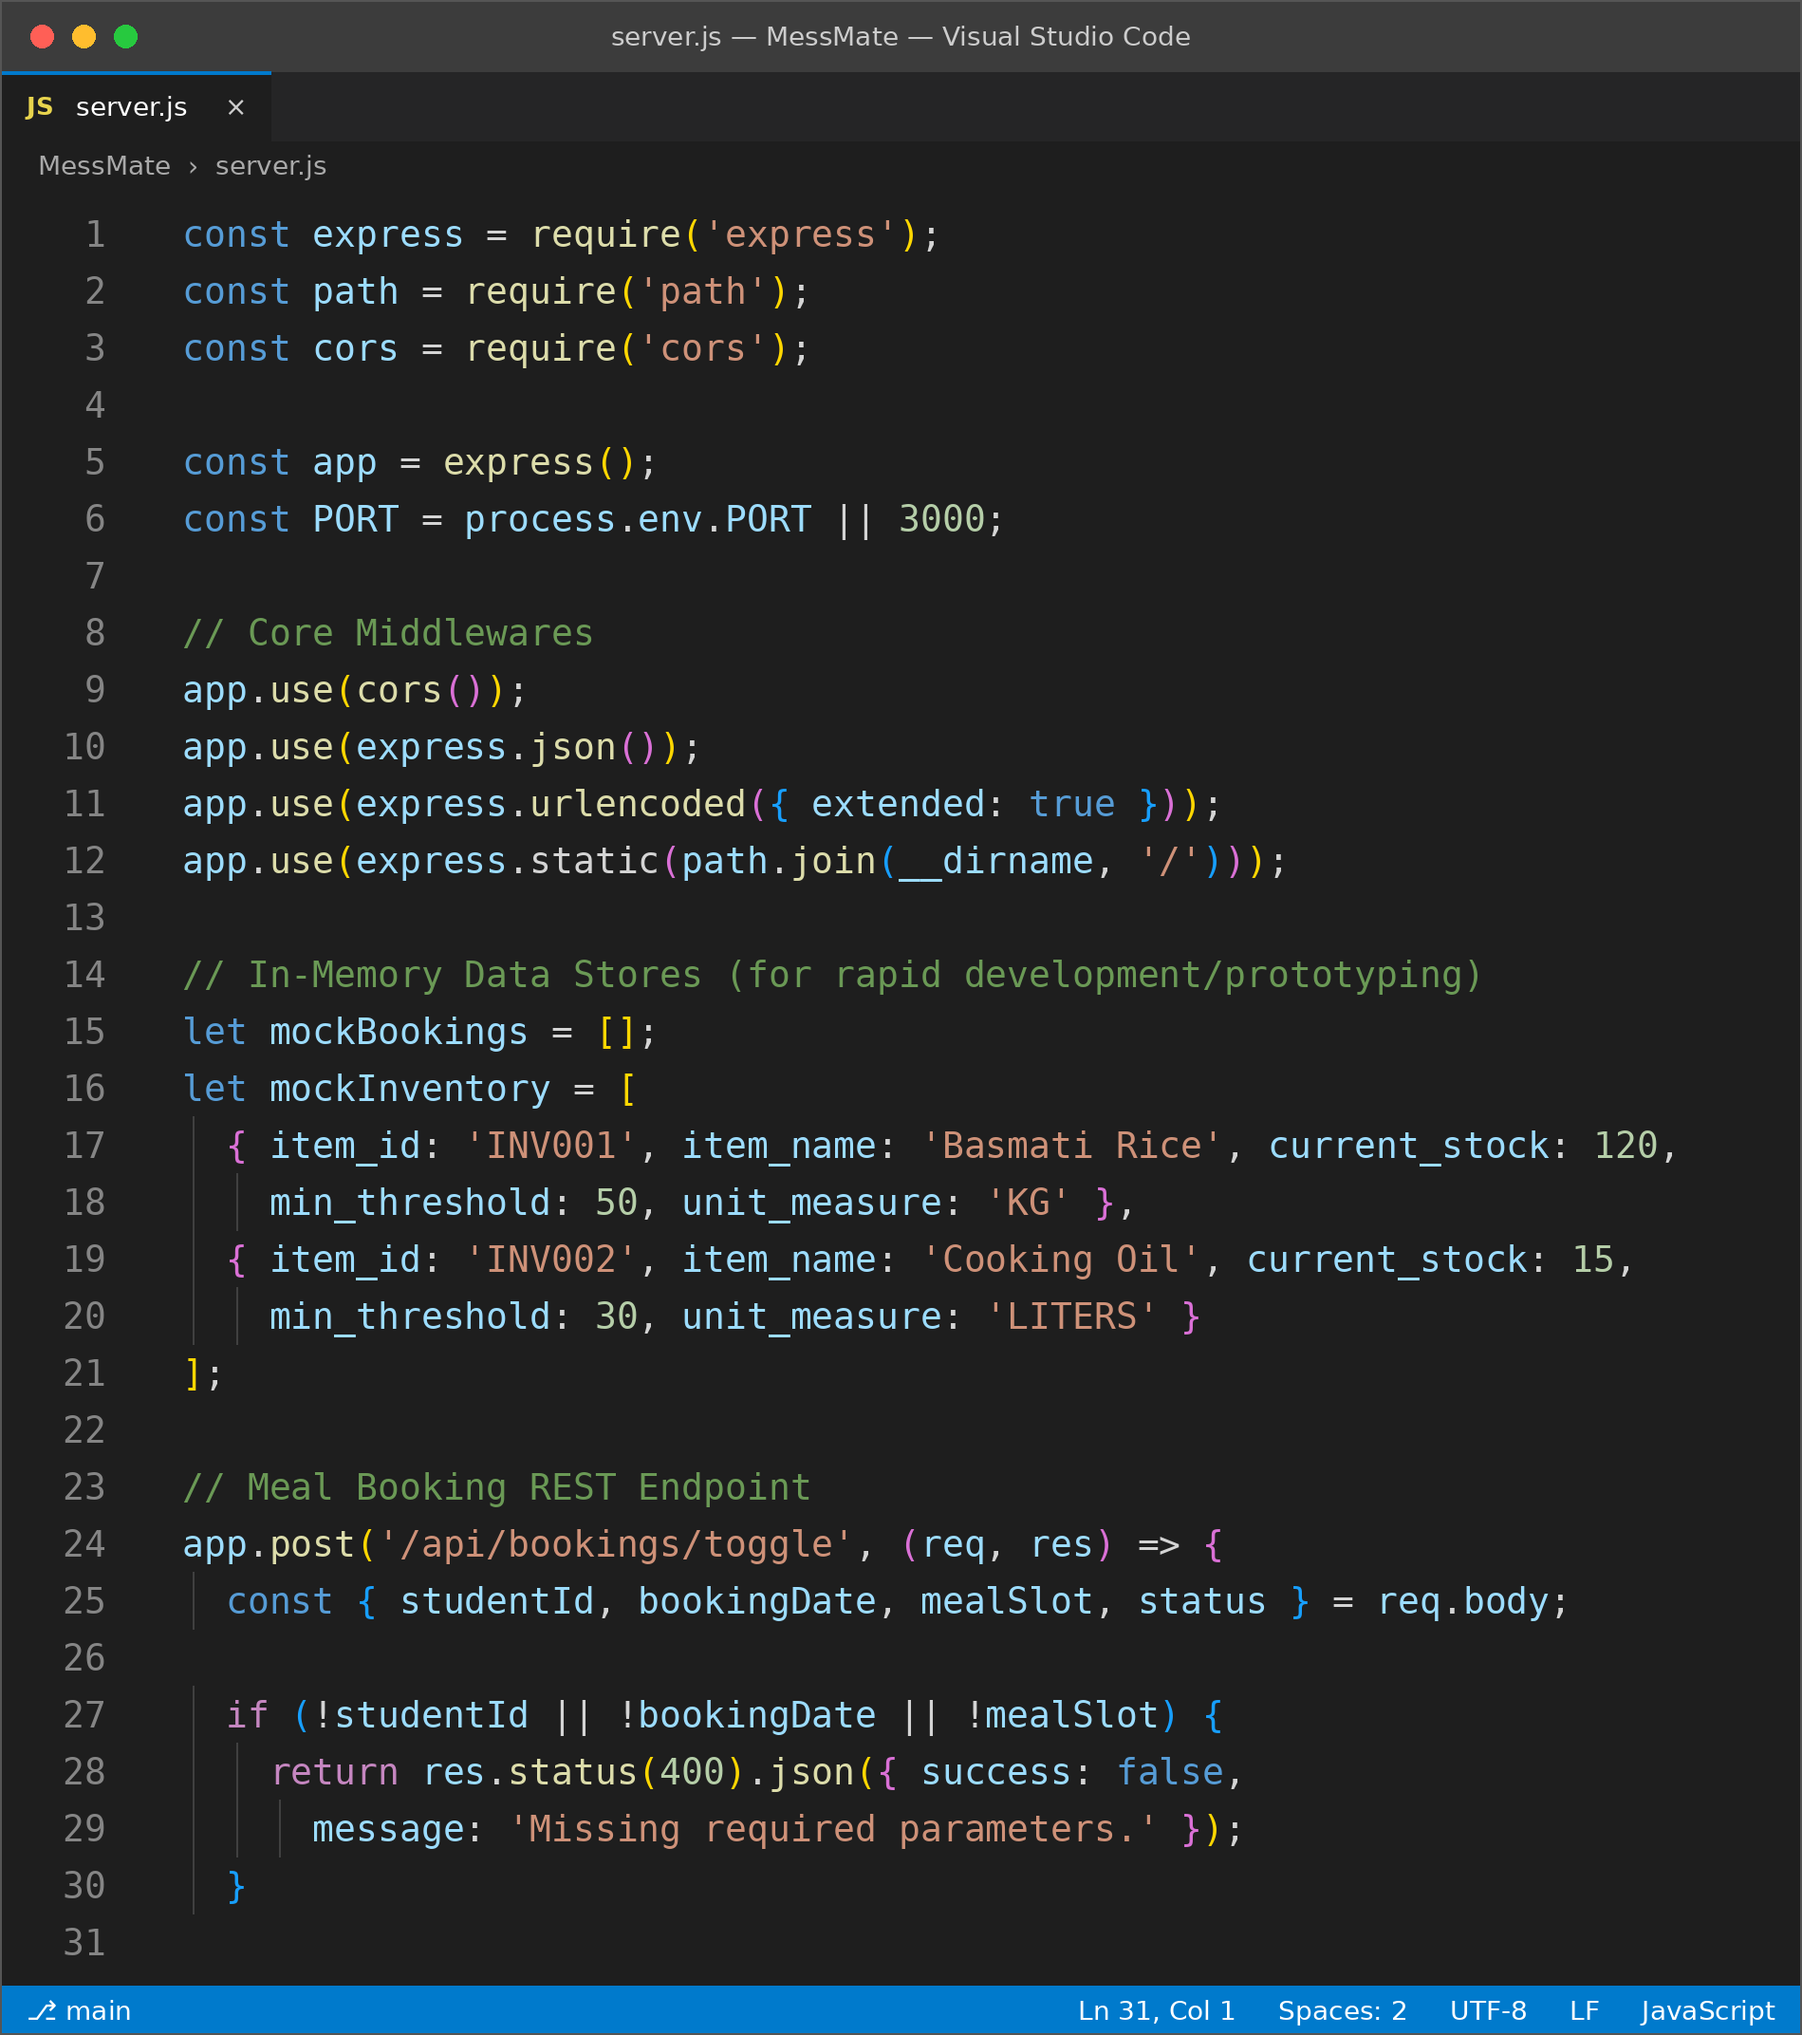
Figure 7.1: server.js in VS Code (part 1 of 3)
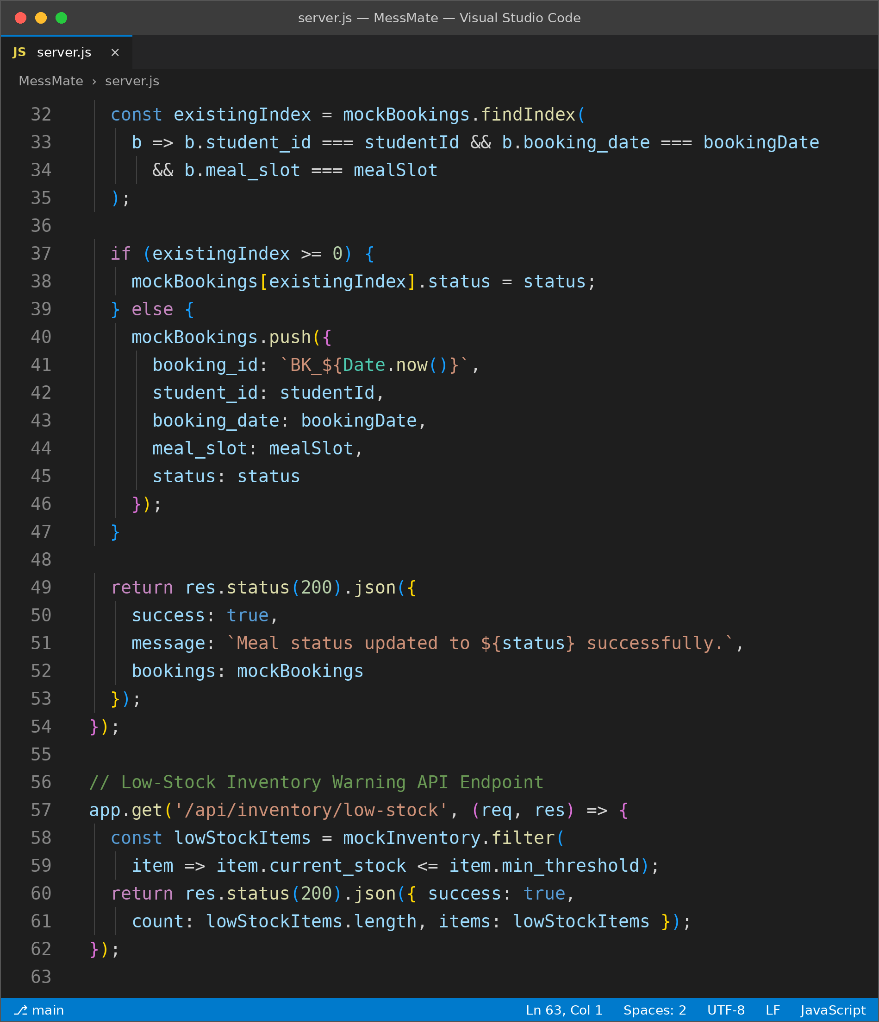
Figure 7.2: server.js in VS Code (part 2 of 3)
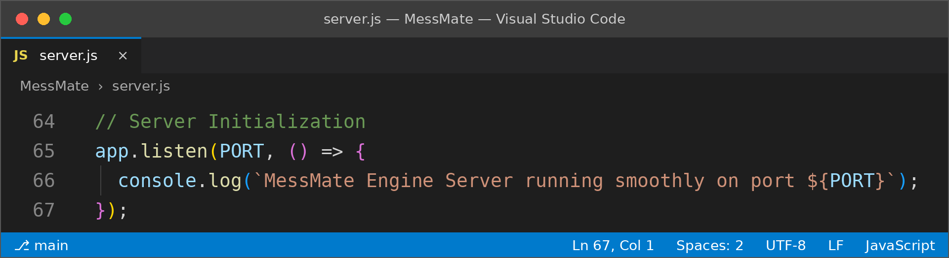
Figure 7.3: server.js in VS Code (part 3 of 3)

7.2 Student Dashboard Handler (js/student-dashboard.js)
Handles client-side meal booking interactions and dynamic QR pass generation.
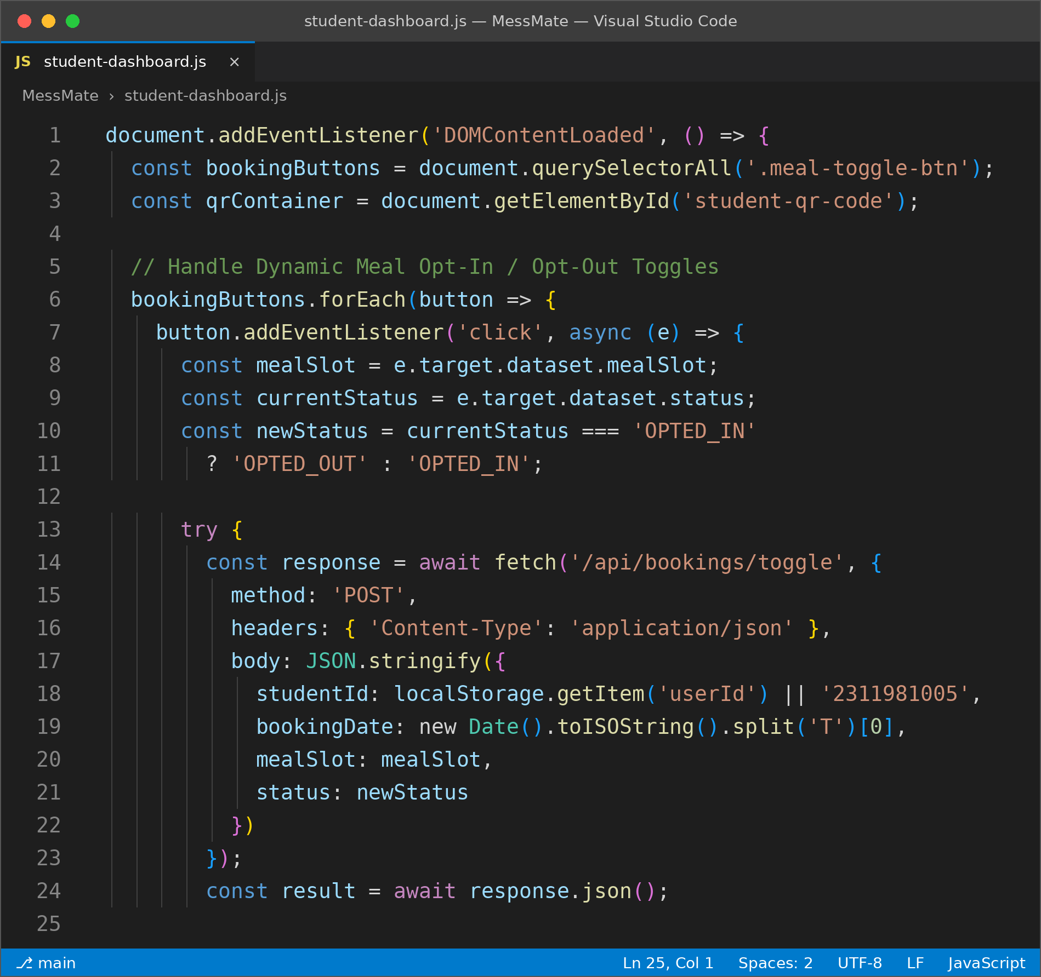
Figure 7.4: student-dashboard.js in VS Code (part 1 of 2)
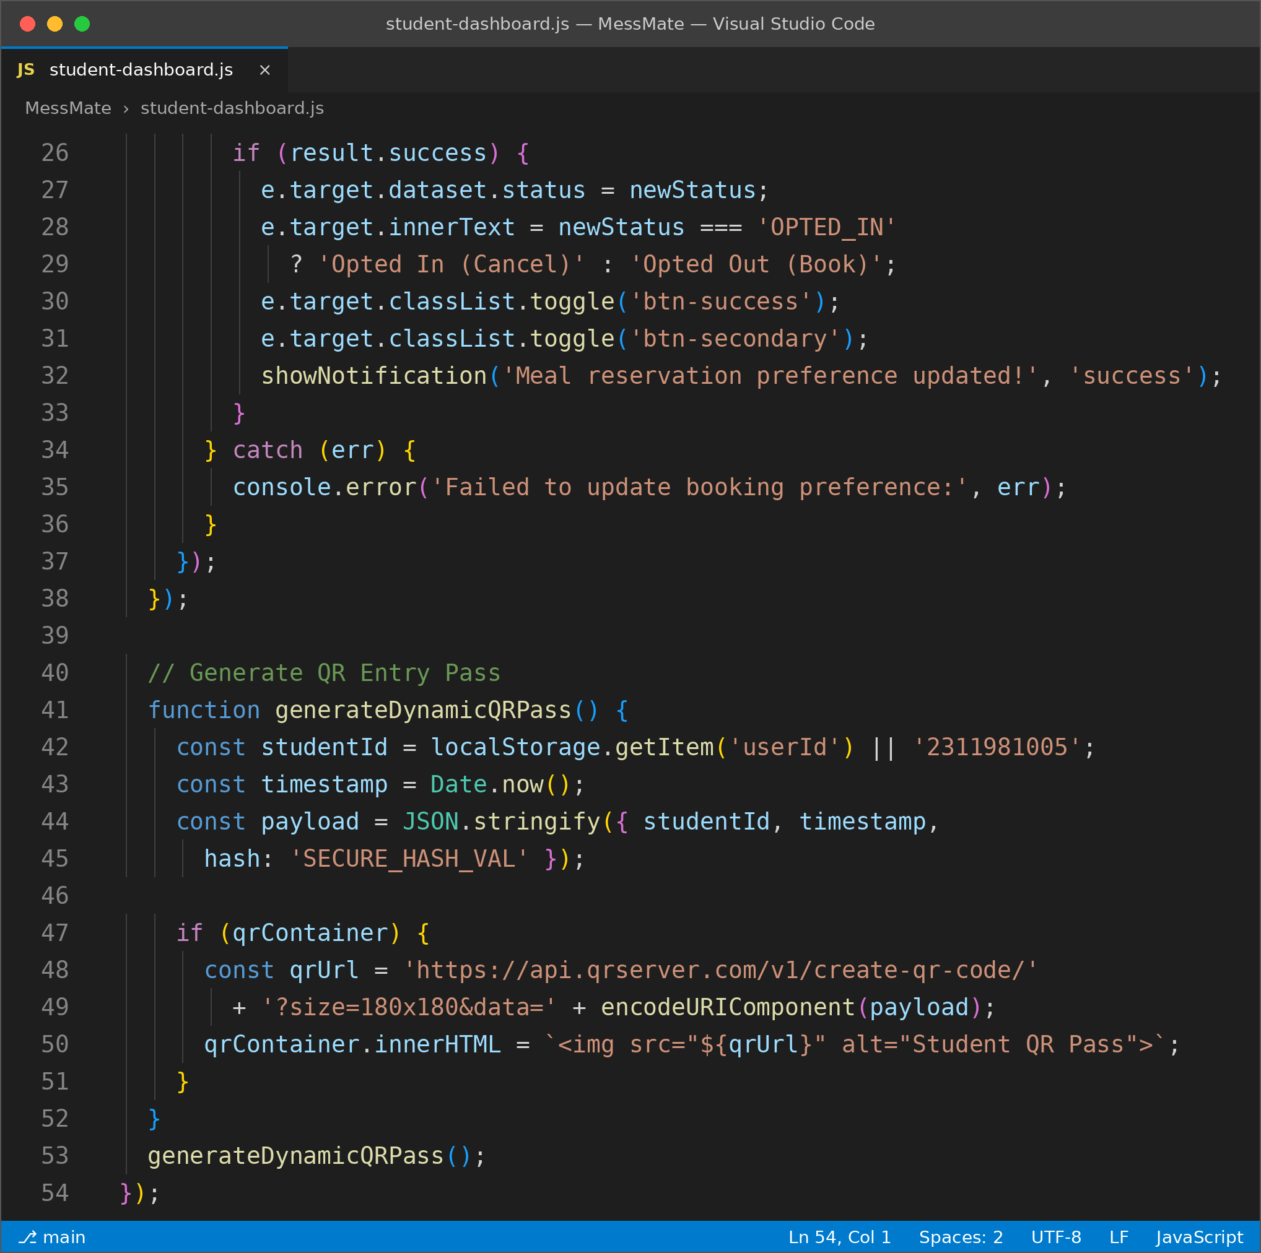
Figure 7.5: student-dashboard.js in VS Code (part 2 of 2)

7.3 Manager Dashboard Handler (js/manager-dashboard.js)
Controls low-stock checks and complaint status management.
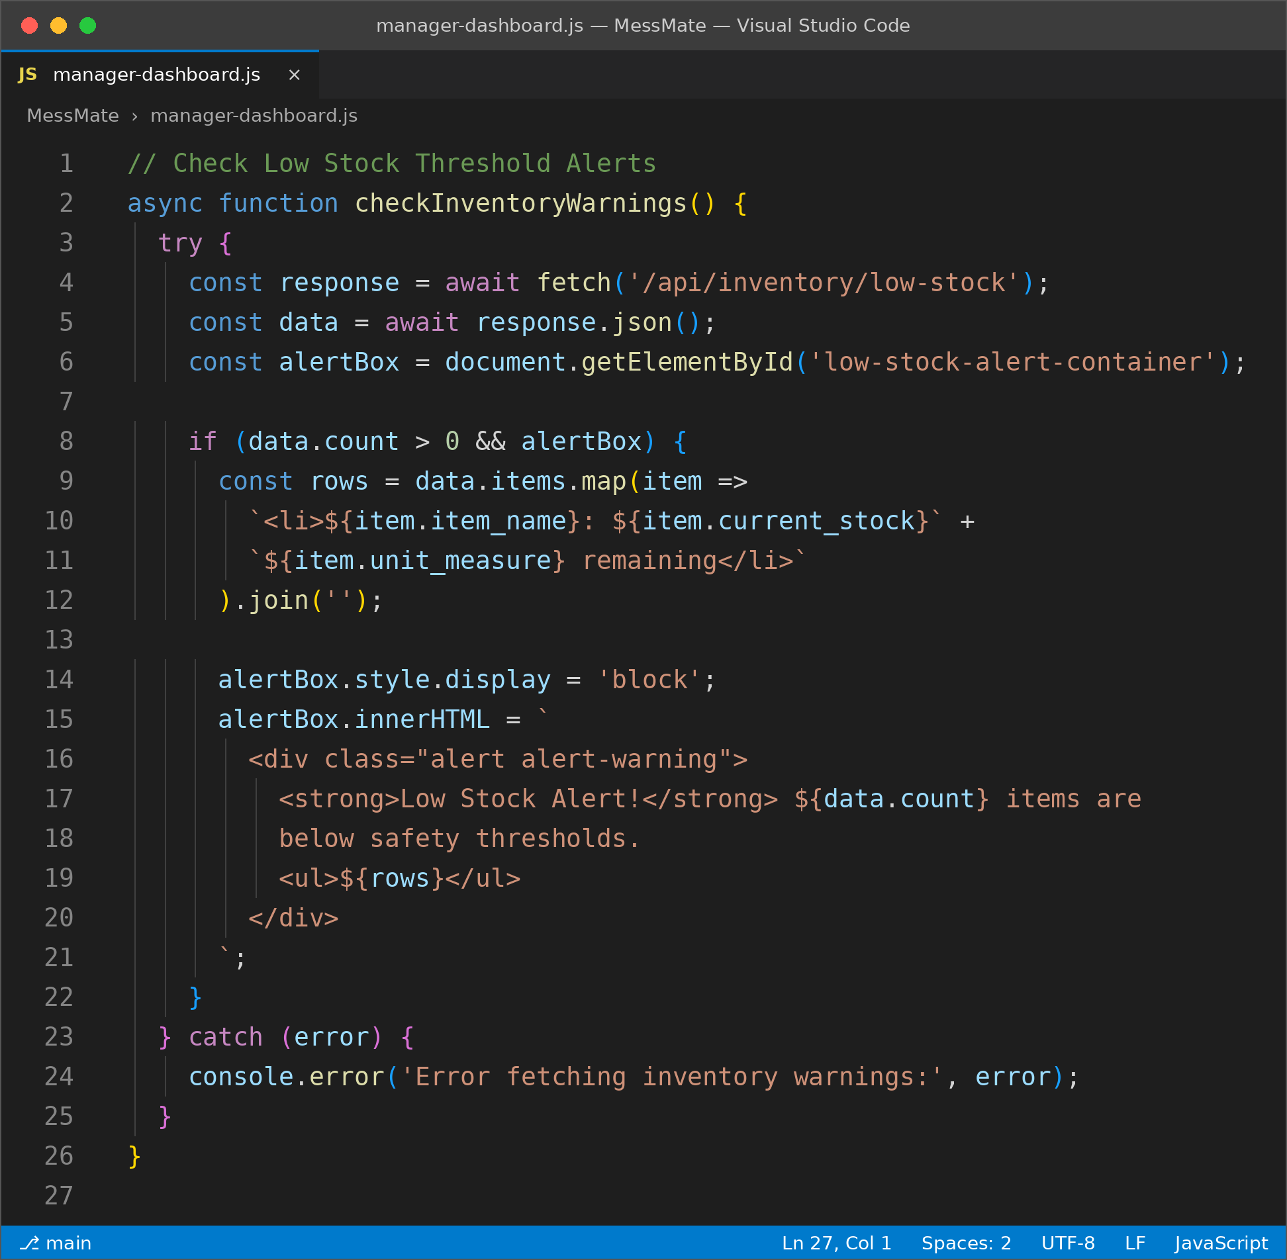
Figure 7.6: manager-dashboard.js in VS Code (part 1 of 2)
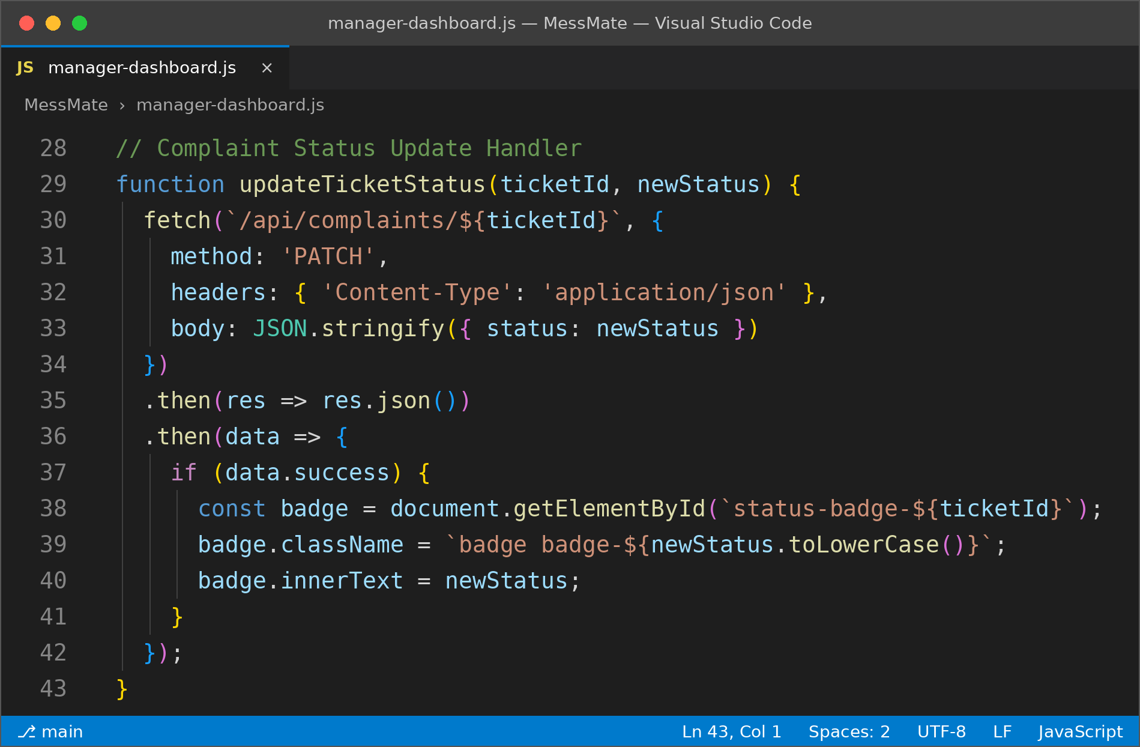
Figure 7.7: manager-dashboard.js in VS Code (part 2 of 2)

8. Testing

8.1 Test Plan and Execution Strategy
The testing methodology verifies application functionality, UI responsiveness, REST API stability and authorization security:
- Unit Testing: individual testing of backend route handlers and helper utilities.
- Integration Testing: verifying that student meal booking toggles are reflected in the Manager Dashboard demand forecast.
- UI and Cross-Browser Testing: responsive layout testing on Google Chrome, Firefox and mobile viewports.
- Security and Auth Testing: ensuring unauthenticated users are redirected away from restricted dashboard pages.

8.2 Test Cases Matrix
Test ID | Module | Scenario and Steps | Expected Outcome | Result
TC01 | Auth Module | Enter valid email and password on signup.html | Auth succeeds, JWT issued, redirect to dashboard | PASS
TC02 | RBAC Security | Access /admin-dashboard.html without JWT token | Access denied; redirected to login portal | PASS
TC03 | Meal Booking | Click meal reservation toggle before cut-off time | Status changes to OPTED_IN; backend record updated | PASS
TC04 | Cut-Off Engine | Cancel lunch booking after 09:00 AM cut-off | Action disabled; cut-off warning banner shown | PASS
TC05 | Attendance | Scan active student QR code at staff entry portal | Verification succeeds; status changed to CONSUMED | PASS
TC06 | Attendance | Scan the same QR code again for the same meal slot | Entry rejected; duplicate entry alert displayed | PASS
TC07 | Inventory | Reduce item quantity below safety threshold | Low-stock banner highlighted on manager dashboard | PASS
TC08 | Grievance | Student submits grievance ticket with image attachment | Ticket logged as Pending; visible to manager | PASS

Table 8.1: Test cases and results

9. Bibliography and References

9.1 Journals
- Sharma, A., & Verma, R. (2019). Challenges in Hostel Administration and Mess Operations in Higher Education Institutions. Journal of Campus Administration & Technology, 12(2), pp. 45–58.
- Kumar, P., & Singh, S. (2020). Design and Development of Web-Based Smart Mess Management System. International Journal of Computer Applications, 178(14), pp. 22–29.
- Patel, K., Mehta, M., & Shah, D. (2021). Automated Mess Access Control using QR Code Verification. IEEE Transactions on Consumer Electronics & Smart Campus, 67(3), pp. 201–209.

9.2 Websites
- Express.js Documentation: Fast, unopinionated, minimalist web framework for Node.js. https://expressjs.com/
- Node.js Runtime Environment: Asynchronous event-driven JavaScript runtime. https://nodejs.org/
- MongoDB Documentation. https://www.mongodb.com/docs/
- PostgreSQL Documentation. https://www.postgresql.org/docs/

